Integrating Meteorological Insights and Machine Learning for Sugarcane Yield Prediction in South Gujarat

ABSTRACT

Accurate crop yield forecasting is essential for sustainable agricultural management and food security. This study leverages meteorological parameters and machine learning techniques to develop a robust yield prediction model for sugarcane in the major sugarcane growing district of Gujarat. This study evaluates the performance of Stepwise Multiple Linear Regression (SMLR) and three machine learning (ML) models: "Artificial Neural Networks (ANN)," "Random Forest Regression (RFR)," and "Support Vector Regression (SVR)" for predicting sugarcane yield in four districts of Gujarat, India (Navsari, Bharuch, Surat, and Tapi).

Keywords: Machine learning, Meteorology, Yield forecasting, Sugarcane, ANN and SMLR

1. Introduction

Sugarcane (Saccharum officinarum) is a vital crop globally due to its widespread use in daily life and its economic importance in both dietary and industrial sectors (Zulu et al., 2019). India ranks as the world's second-largest producer of sugar, following Brazil, and its sugar industry is also the country's second-biggest agro-processing sector (Tyagi et al., 2023).

2. Study Area and Data

2.1 Study Area

The key sugarcane-growing districts of South Gujarat were selected for this study due to their significant contributions to the state's sugarcane cultivation (Figure 1). These four districts—Bharuch, Surat, Tapi, and Navsari—collectively account for approximately 83% of Gujarat's total sugarcane area and production.

2.2 Data

The study employed meteorological data collected over a 21-year period (2001–2021), which included variables such as maximum temperature (Tmax), minimum temperature (Tmin),

3. Methodology

3.1 Generation of Weather Indices

Daily meteorological observations were converted into weekly averages to develop weather indices. The unweighted

3.2 Yield Forecasting Models Development

3.2.1 SMLR

“Stepwise regression is a technique for constructing regression models where the selection of predictive variables is automated.” At every stage, variables were assessed

3.2.2 ML Model

The research utilized three machine learning algorithms-RFR, SVR, and ANN-each known for their unique strengths. The selection of these models was guided by the specific features and complexity of the dataset (Table 1). Since no single

4. Results and Discussion

4.1 Overview of sugarcane yield variability across the forecasting districts

The summary statistics for the yield data from the four districts of Gujarat (Navsari, Bharuch, Surat, and Tapi) are

5. Conclusion

This study presents an affordable method for estimating sugarcane yield by examining the correlation between weather indices and annual yield. The accuracy and performance of different models vary according to the district. The ANN model demonstrates superior forecasting accuracy among the selected models due to its ability to capture complex, non-linear relationships between input features, such as weather indices. Based on the study, when only meteorological data is available, the ANN model is the most effective choice for yield forecasting due to its capacity to model these complex relationships.
References

Allen, M.R., Dube, O.P., Solecki, W., Aragón-Durand, F., Cramer, W., Humphreys, S., & Zickfeld, K. (2018). Framing and context. Global Warming of 1.5°C: An IPCC Special Report on the Impacts of Global Warming of 1.5°C Above Pre-Industrial Levels.

Cannon, A.J., Sobie, S.R., & Murdock, T.Q. (2015). Bias correction of GCM precipitation by quantile mapping: How well do methods preserve changes in quantiles and extremes? Journal of Climate, 28(17), 6938–6959.

Enayati, M., Bozorg-Haddad, O., Bazrafshan, J., Hejabi, S., & Chu, X. (2021). Bias correction capabilities of quantile mapping methods for rainfall and temperature variables. Journal of Water and Climate Change, 12(2), 401–419.

Zhang, X.C., Wu, J.W., Wu, H.Y., & Li, Y. (2011). Simplified SEBAL method for estimating vast areal evapotranspiration with MODIS data. Water Science and Engineering, 4(1), 24–35.

Table 1 Unweighted and weighted weather indices
Parameter | Unweighted Weather Indices |  |  |  |  |  | Weighted Weather Indices
Parameter | Tmax | Tmin | RF | RH-I | RH-II | BSSH | Tmax | Tmin | RF | RH-I | RH-II | BSSH
Tmax | Z10 |  |  |  |  |  | Z11
Tmin | Z120 | Z20 |  |  |  |  | Z121 | Z21
RF (rainfall) | Z130 | Z230 | Z30 |  |  |  | Z131 | Z231 | Z31
RH-I_{morning} | Z140 | Z240 | Z340 | Z40 |  |  | Z141 | Z241 | Z341 | Z41
RH-II_{afternoon} | Z150 | Z250 | Z350 | Z450 | Z50 |  | Z151 | Z251 | Z351 | Z451 | Z51
BSSH | Z160 | Z260 | Z360 | Z460 | Z560 | Z60 | Z161 | Z261 | Z361 | Z461 | Z561 | Z61
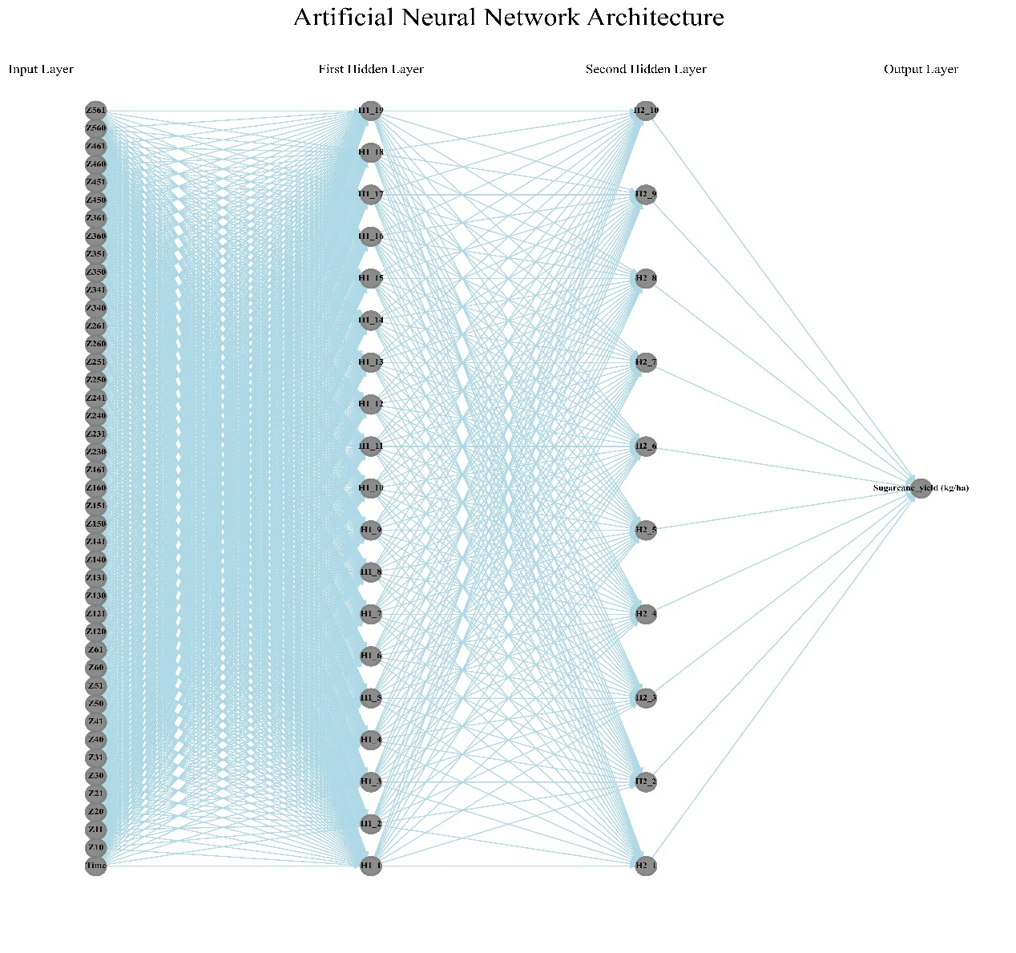
Fig. 1. Architecture of ANN model

